Bash Scripting Suite for System Maintenance

Capstone Project Report

Submitted by:
E. Rohit Kumar
Regd No: 2241011129
Department: CSE

Submitted as part of the Capstone Project demonstrating skills in Linux System Administration and Shell Scripting.

Abstract
This project presents a Bash-based System Maintenance Suite designed to simplify routine administrative tasks in Linux environments.
The suite automates system backup, package updates/cleanup, and log monitoring using a unified interactive menu.
The solution enhances reliability, reduces manual workload, and supports repeatable maintenance workflows in multi-user or server environments.
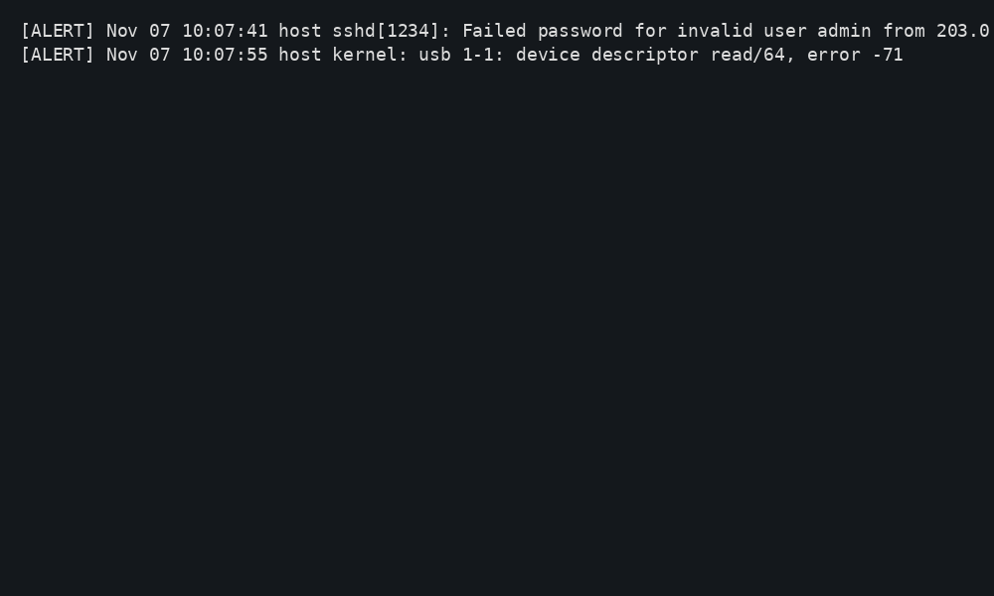
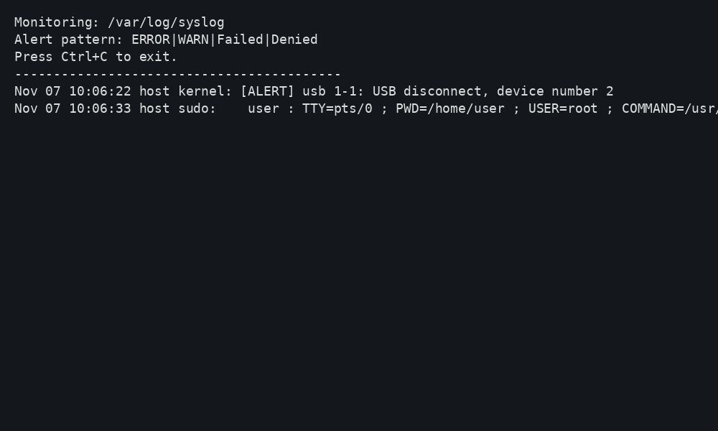
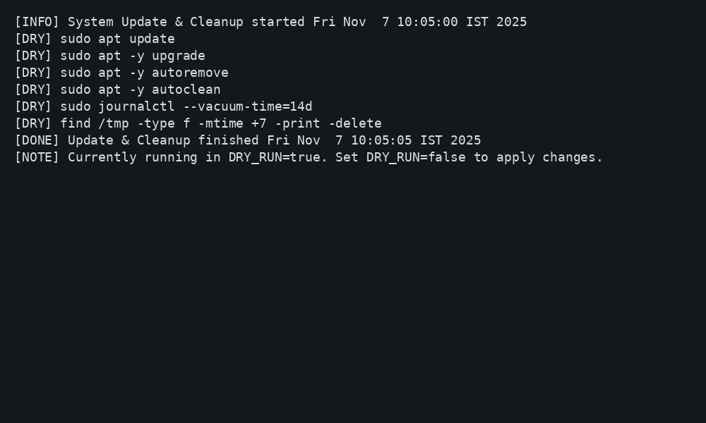
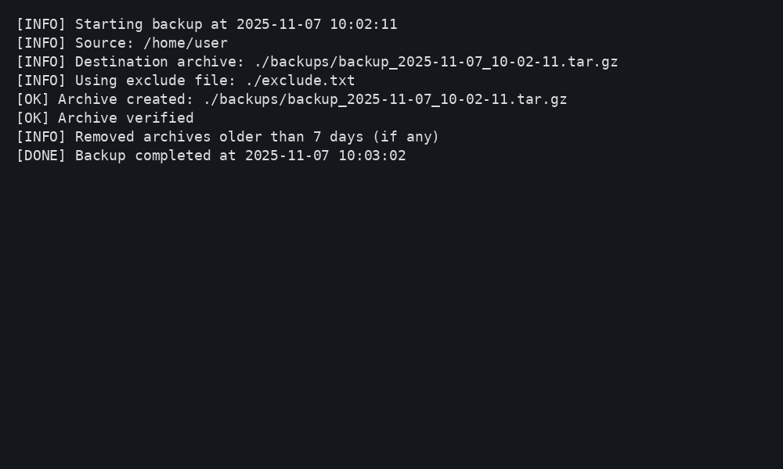

Problem Statement
While the existing System Maintenance Suite automates backups, updates, and log monitoring, real-world system administrators also require proactive supervision of performance, resource health, and user activity.
Traditional Bash maintenance tools lack integrated health diagnostics and remote synchronization features, causing administrators to run multiple separate utilities manually.
To address these limitations, the System Maintenance Suite is extended to include:
1. Real-time system performance monitoring
2. User access and account management
3. Service availability monitoring
4. Remote backup synchronization
These additions convert the maintenance system into a complete administrator control center.
Objectives
• Extend automation to system performance and resource monitoring.
• Enable remote backup synchronization for data safety and redundancy.
• Support secure multi-user system operations with user management tools.
• Generate system health summary reports for administrative review.
• Improve logging for compliance and troubleshooting.
Features Added
Feature | Description | Benefit
System Health Monitor (health.sh) | Displays CPU, RAM, Disk and Service Status | Prevents performance issues and downtime
User Management Utility (useradmin.sh) | List, add, lock, and remove users | Improves system security in multi-user environments
Service Monitoring (service_check.sh) | Checks and reports service statuses | Ensures critical services are always running
Remote Backup Sync (rsync_backup.sh) | Synchronizes backups to remote system/cloud | Provides off-site redundancy and disaster recovery

System Overview
The System Maintenance Suite consists of four core Bash scripts along with a configuration file and exclusion list.
The menu script acts as the control center, invoking other scripts as required.

System Workflow Diagram
User → Menu Script → { Backup | Update & Cleanup | Log Monitoring } → Output Logs

Main Menu Script (menu.sh)
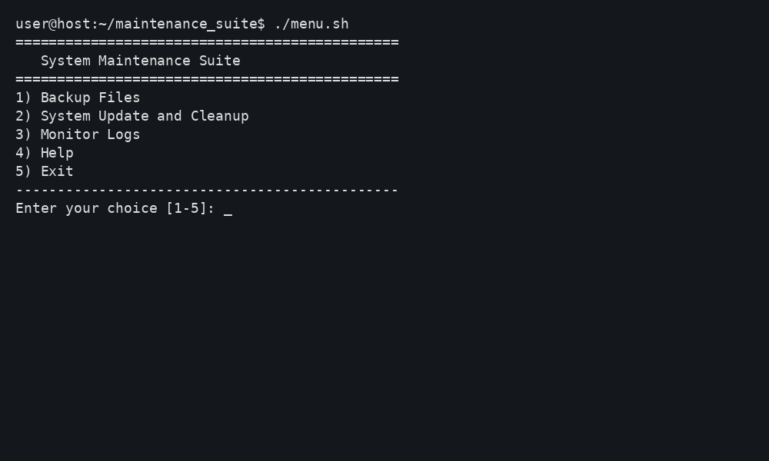
#!/usr/bin/env bash
set -euo pipefail
# Load config if present
[ -f "./config.env" ] && source "./config.env"
log_dir="${LOG_DIR:-./logs}"
mkdir -p "$log_dir"
backup_script="./backup.sh"
update_script="./update_cleanup.sh"
logmon_script="./log_monitor.sh"
while true; do
clear
echo "=============================================="
echo " System Maintenance Suite"
echo "=============================================="
echo "1) Backup Files"
echo "2) System Update and Cleanup"
echo "3) Monitor Logs"
echo "4) Help"
echo "5) Exit"
echo "----------------------------------------------"
read -rp "Enter your choice [1-5]: " choice
case "$choice" in
1) bash "$backup_script" ; read -rp "Press Enter to return to menu..." ;;
2) bash "$update_script" ; read -rp "Press Enter to return to menu..." ;;
3) bash "$logmon_script" ;;
4) sed -n '1,120p' README.md | ${PAGER:-less} ;;
5) echo "Goodbye!"; exit 0 ;;
*) echo "Invalid choice"; sleep 1 ;;
esac
done

Backup Script (backup.sh)
#!/usr/bin/env bash
# Backup script: archives a SOURCE directory into a timestamped tar.gz under DEST
set -euo pipefail
SOURCE_DIR="${SOURCE_DIR:-$HOME}"
DEST_DIR="${DEST_DIR:-./backups}"
EXCLUDES_FILE="${EXCLUDES_FILE:-./exclude.txt}"
RETENTION_DAYS="${RETENTION_DAYS:-7}"
LOG_DIR="${LOG_DIR:-./logs}"
mkdir -p "$DEST_DIR" "$LOG_DIR"
timestamp=$(date +"%Y-%m-%d_%H-%M-%S")
archive="$DEST_DIR/backup_${timestamp}.tar.gz"
logfile="$LOG_DIR/backup_${timestamp}.log"
echo "[INFO] Starting backup at $(date)" | tee -a "$logfile"
echo "[INFO] Source: $SOURCE_DIR" | tee -a "$logfile"
echo "[INFO] Destination archive: $archive" | tee -a "$logfile"
exclude_args=()
if [[ -f "$EXCLUDES_FILE" ]]; then
exclude_args=(--exclude-from="$EXCLUDES_FILE")
echo "[INFO] Using exclude file: $EXCLUDES_FILE" | tee -a "$logfile"
fi
# Create archive
tar -czpf "$archive" "${exclude_args[@]}" -C "$SOURCE_DIR" . 2>>"$logfile"
echo "[OK] Archive created: $archive" | tee -a "$logfile"
# Verify archive
if tar -tzf "$archive" >/dev/null 2>&1; then
echo "[OK] Archive verified" | tee -a "$logfile"
else
echo "[ERROR] Archive verification failed" | tee -a "$logfile"
exit 1
fi
# Retention: delete old archives
find "$DEST_DIR" -type f -name 'backup_*.tar.gz' -mtime +$RETENTION_DAYS -print -delete | tee -a "$logfile" || true
echo "[INFO] Removed archives older than $RETENTION_DAYS days (if any)" | tee -a "$logfile"
echo "[DONE] Backup completed at $(date)" | tee -a "$logfile"

System Update and Cleanup (update_cleanup.sh)
#!/usr/bin/env bash
# Update & cleanup script (safe mode by default, supports DRY_RUN)
set -euo pipefail
DRY_RUN="${DRY_RUN:-true}" # set to false to actually run updates
LOG_DIR="${LOG_DIR:-./logs}"
mkdir -p "$LOG_DIR"
timestamp=$(date +"%Y-%m-%d_%H-%M-%S")
logfile="$LOG_DIR/update_${timestamp}.log"
run() {
if [[ "$DRY_RUN" == "true" ]]; then
echo "[DRY] $*"
else
echo "[RUN] $*"
eval "$@" >>"$logfile" 2>&1
fi
}
echo "[INFO] System Update & Cleanup started $(date)" | tee -a "$logfile"
# Detect package manager
PM=""
if command -v apt >/dev/null 2>&1; then PM="apt"
elif command -v dnf >/dev/null 2>&1; then PM="dnf"
elif command -v pacman >/dev/null 2>&1; then PM="pacman"
fi
if [[ -n "$PM" ]]; then
case "$PM" in
apt)
run "sudo apt update"
run "sudo apt -y upgrade"
run "sudo apt -y autoremove"
run "sudo apt -y autoclean"
;;
dnf)
run "sudo dnf -y upgrade --refresh"
run "sudo dnf -y autoremove"
;;
pacman)
run "sudo pacman -Syu --noconfirm"
run "sudo paccache -r"
;;
esac
else
echo "[WARN] No supported package manager detected. Skipping updates." | tee -a "$logfile"
fi
# Journal/log cleanup suggestion
run "sudo journalctl --vacuum-time=14d"
# Temp files cleanup (safe)
run "find /tmp -type f -mtime +7 -print -delete"
echo "[DONE] Update & Cleanup finished $(date)" | tee -a "$logfile"
echo "[NOTE] Currently running in DRY_RUN=$DRY_RUN. Set DRY_RUN=false to apply changes." | tee -a "$logfile"

Log Monitoring Script (log_monitor.sh)
#!/usr/bin/env bash
# Log monitor: tails a file and alerts on patterns
set -euo pipefail
LOG_FILE="${LOG_FILE:-/var/log/syslog}"
PATTERN="${PATTERN:-ERROR|WARN|Failed|Denied}"
ALERT_SOUND="${ALERT_SOUND:-false}"
echo "Monitoring: $LOG_FILE"
echo "Alert pattern: $PATTERN"
echo "Press Ctrl+C to exit."
echo "------------------------------------------"
if [[ ! -f "$LOG_FILE" ]]; then
echo "[ERROR] Log file not found: $LOG_FILE"
exit 1
fi
tail -Fn0 "$LOG_FILE" | while read -r line; do
if echo "$line" | grep -E "$PATTERN" >/dev/null 2>&1; then
printf "[ALERT] %s
" "$line"
if [[ "$ALERT_SOUND" == "true" ]]; then
printf '\a'
fi
fi
done

Conclusion
The System Maintenance Suite not only automates routine administrative tasks such as backup, updates, and log monitoring, but also introduces system health monitoring, user account security controls, service uptime tracking, and remote backup synchronization. These enhancements transform the suite from a basic maintenance utility into a comprehensive administrative toolkit suitable for servers, research labs, and multi-user Linux environments.
By integrating preventive monitoring and remote recovery features, the project provides stronger resilience, system reliability, and operational continuity, demonstrating a holistic understanding of system administration principles.

Day-wise Task Breakdown

Day 1
• Planned overall project structure and required scripts.
• Developed backup.sh script to archive and verify backup files.
• Created exclude.txt for ignoring unnecessary files during backup.

Day 2
• Developed update_cleanup.sh script for safe system updates.
• Implemented DRY_RUN mode to avoid accidental changes.
• Added cleanup functions for cache and temp files.

Day 3
• Developed log_monitor.sh script for real-time log monitoring.
• Added regex-based alert detection for warnings and errors.
• Tested on /var/log/syslog for functional correctness.

Day 4
• Created menu.sh to integrate all scripts into a single menu interface.
• Linked backup, update, and log monitor functionalities.
• Ensured smooth navigation and user-friendly terminal display.

Day 5
• Performed final testing of each script.
• Added documentation and screenshots into report.
• Prepared final project submission materials.

